Homework 2

Xiao Wang

# Question 4.1

Describe a situation or problem from your job, everyday life, current events, etc., for which a clustering model would be appropriate. List some (up to 5) predictors that you might use.

A university may want to find out the pattern of the alumni who make donations. Predictors:

1. Highest degree of education
2. Major
3. Length of the stay in this university
4. If received any kind of finicial aids from the university
5. Annual income

# Question 4.2

Use the R function kmeans to cluster the points as well as possible. Report the best combination of predictors, your suggested value of k, and how well your best clustering predicts flower type.

head(iris)

## Sepal.Length Sepal.Width Petal.Length Petal.Width Species  
## 1 5.1 3.5 1.4 0.2 setosa  
## 2 4.9 3.0 1.4 0.2 setosa  
## 3 4.7 3.2 1.3 0.2 setosa  
## 4 4.6 3.1 1.5 0.2 setosa  
## 5 5.0 3.6 1.4 0.2 setosa  
## 6 5.4 3.9 1.7 0.4 setosa

str(iris)

## 'data.frame': 150 obs. of 5 variables:  
## $ Sepal.Length: num 5.1 4.9 4.7 4.6 5 5.4 4.6 5 4.4 4.9 ...  
## $ Sepal.Width : num 3.5 3 3.2 3.1 3.6 3.9 3.4 3.4 2.9 3.1 ...  
## $ Petal.Length: num 1.4 1.4 1.3 1.5 1.4 1.7 1.4 1.5 1.4 1.5 ...  
## $ Petal.Width : num 0.2 0.2 0.2 0.2 0.2 0.4 0.3 0.2 0.2 0.1 ...  
## $ Species : Factor w/ 3 levels "setosa","versicolor",..: 1 1 1 1 1 1 1 1 1 1 ...

Only keep the predictor variables

iris4.2<-iris[,1:4]  
head(iris4.2)

## Sepal.Length Sepal.Width Petal.Length Petal.Width  
## 1 5.1 3.5 1.4 0.2  
## 2 4.9 3.0 1.4 0.2  
## 3 4.7 3.2 1.3 0.2  
## 4 4.6 3.1 1.5 0.2  
## 5 5.0 3.6 1.4 0.2  
## 6 5.4 3.9 1.7 0.4

Scale to the normal distribution

meansl=mean(iris4.2$Sepal.Length)  
sdsl=sd(iris4.2$Sepal.Length)  
  
meansw=mean(iris4.2$Sepal.Width)  
sdsw=sd(iris4.2$Sepal.Width)  
  
meanpl=mean(iris4.2$Petal.Length)  
sdpl=sd(iris4.2$Petal.Length)  
  
meanpw=mean(iris4.2$Petal.Width)  
sdpw=sd(iris4.2$Petal.Width)  
  
attach(iris4.2)  
iris4.2$s.lgth<-(Sepal.Length-meansl)/sdsl  
iris4.2$s.wdth<-(Sepal.Width-meansw)/sdsw  
iris4.2$p.lgth<-(Petal.Length-meanpl)/sdpl  
iris4.2$p.wdth<-(Petal.Width-meanpw)/sdpw

Only keep the scaled data

irisf<-iris4.2[,5:8]  
head(irisf)

## s.lgth s.wdth p.lgth p.wdth  
## 1 -0.8976739 1.01560199 -1.335752 -1.311052  
## 2 -1.1392005 -0.13153881 -1.335752 -1.311052  
## 3 -1.3807271 0.32731751 -1.392399 -1.311052  
## 4 -1.5014904 0.09788935 -1.279104 -1.311052  
## 5 -1.0184372 1.24503015 -1.335752 -1.311052  
## 6 -0.5353840 1.93331463 -1.165809 -1.048667

set.seed(1234)

# Method 1. Using all predictors (Septal Length, Septal Width,Petal Length, and Petal Width)

k2 <- kmeans(irisf, centers= 2, nstart = 25)  
k3 <- kmeans(irisf, centers = 3, nstart = 25)  
k4 <- kmeans(irisf, centers = 4, nstart = 25)  
k5 <- kmeans(irisf, centers = 5, nstart = 25)

# Function to compute total within-cluster sum of square

wss <- function(k) {  
 kmeans(irisf, k, nstart = 25 )$tot.withinss  
}

# Compute and plot wss for k = 1 to k = 15

kvalues <- 1:15

# Extract wss for 1-15 clusters

wss_values <- map_dbl(kvalues, wss)

plot(kvalues, wss_values, type=“b”, pch = 19, frame = FALSE, xlab=“Number of clusters K”, ylab=“Total within-clusters sum of squares”)

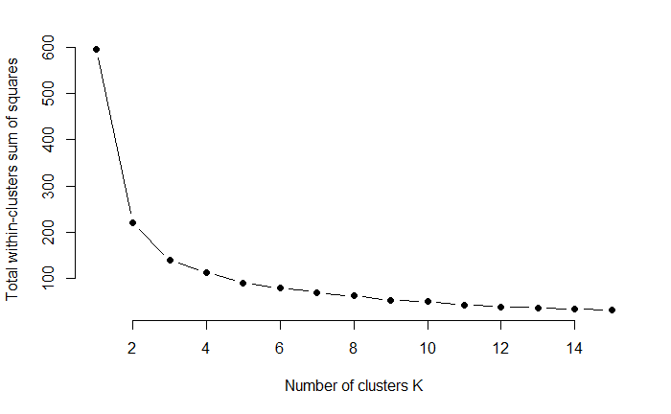

3 is the desired number of clusters

table(k3$cluster, iris$Species)

##   
## setosa versicolor virginica  
## 1 50 0 0  
## 2 0 39 14  
## 3 0 11 36

All the setosa was perfectly clustered in one group, while the versicolor and virginica were clustered in 2 groups.

# Method 2. Using Two predictors (Septal Length, Septal Width)

slw2 <- kmeans(irisf[,1:2], centers= 2, nstart = 25)  
slw3 <- kmeans(irisf[,1:2], centers = 3, nstart = 25)  
slw4 <- kmeans(irisf[,1:2], centers = 4, nstart = 25)  
slw5 <- kmeans(irisf[,1:2], centers = 5, nstart = 25)

# Function to compute total within-cluster sum of square

wssslw <- function(k) {  
 kmeans(irisf[1:2], k, nstart = 25 )$tot.withinss  
}

# Extract wss for 1-15 clusters

wss_valuesslw <- map_dbl(kvalues, wssslw) #kvalues are the same to the previous, which was 1:15

plot(kvalues, wss_valuesslw, type=“b”, pch = 19, frame = FALSE, xlab=“Number of clusters K”, ylab=“Total within-clusters sum of squares”)

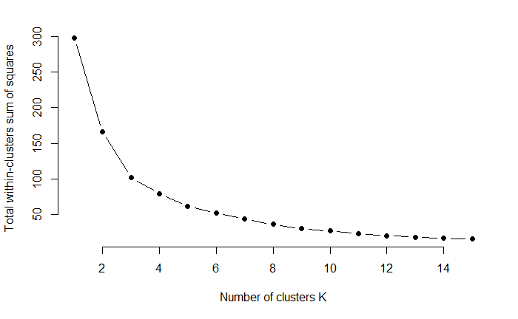

Same to the previous one, 3 is the desired number of clusters, where we got significant improvement.

table(slw3$cluster, iris$Species)

##   
## setosa versicolor virginica  
## 1 0 14 31  
## 2 1 36 19  
## 3 49 0 0

Compare to the previous method, I don’t see great improvement in this one. Instead, setosa species was clustered into two groups.

# Method 3. Using Two predictors (Pettal Length, Pettal Width)

plw2 <- kmeans(irisf[,3:4], centers= 2, nstart = 25)  
plw3 <- kmeans(irisf[,3:4], centers = 3, nstart = 25)  
plw4 <- kmeans(irisf[,3:4], centers = 4, nstart = 25)  
plw5 <- kmeans(irisf[,3:4], centers = 5, nstart = 25)

# Function to compute total within-cluster sum of square

wssplw <- function(k) {  
 kmeans(irisf[3:4], k, nstart = 25 )$tot.withinss  
}

# Extract wss for 1-15 clusters

wss_valuesplw <- map_dbl(kvalues, wssplw)

plot(kvalues, wss_valuesplw, type=“b”, pch = 19, frame = FALSE, xlab=“Number of clusters K”, ylab=“Total within-clusters sum of squares”)

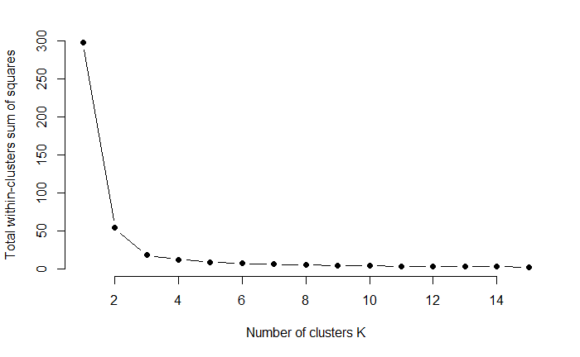

Same to the previous ones, 3 is the desired number of clusters,where we got significant improvement.

table(plw3$cluster, iris$Species)

##   
## setosa versicolor virginica  
## 1 50 0 0  
## 2 0 2 46  
## 3 0 48 4

# Plots for visualization

p3 <- fviz_cluster(plw3, geom = “point”, data = irisf) + ggtitle(“k = 3”) grid.arrange(p3)

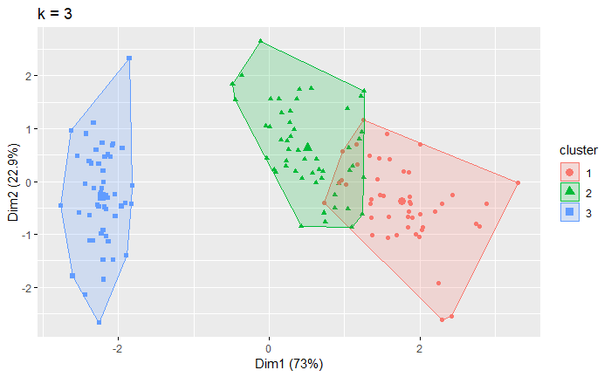

Compare to the previous methods, this one is much better: Setosa was perfectly clustered as the method 1 (also shown in the picture above), and versicolor and virginica were also nicely clustered with only 2-4 misclassification. I would recommend to use Pettal Length and Pettal Width as predictors, k value equals to 3 for this model. It can correctly predicts 144 out of 150 cluters.

# Using crime data from the file uscrime.txt (<http://www.statsci.org/data/general/uscrime.txt>,description at <http://www.statsci.org/data/general/uscrime.html>), test to see whether there are any outliers in the last column (number of crimes per 100,000 people). Use the grubbs.test function in the outliers package in R.

crime<- read.table("http://www.statsci.org/data/general/uscrime.txt",header=TRUE)  
head(crime)

## M So Ed Po1 Po2 LF M.F Pop NW U1 U2 Wealth Ineq  
## 1 15.1 1 9.1 5.8 5.6 0.510 95.0 33 30.1 0.108 4.1 3940 26.1  
## 2 14.3 0 11.3 10.3 9.5 0.583 101.2 13 10.2 0.096 3.6 5570 19.4  
## 3 14.2 1 8.9 4.5 4.4 0.533 96.9 18 21.9 0.094 3.3 3180 25.0  
## 4 13.6 0 12.1 14.9 14.1 0.577 99.4 157 8.0 0.102 3.9 6730 16.7  
## 5 14.1 0 12.1 10.9 10.1 0.591 98.5 18 3.0 0.091 2.0 5780 17.4  
## 6 12.1 0 11.0 11.8 11.5 0.547 96.4 25 4.4 0.084 2.9 6890 12.6  
## Prob Time Crime  
## 1 0.084602 26.2011 791  
## 2 0.029599 25.2999 1635  
## 3 0.083401 24.3006 578  
## 4 0.015801 29.9012 1969  
## 5 0.041399 21.2998 1234  
## 6 0.034201 20.9995 682

crime<-crime$Crime

# Test if the lowest and highest value are two outliers on opposite tails of sample.

grubbs.test(crime,type=11)

|  |
| --- |
| Grubbs test for two opposite outliers  data: crime  G = 4.26880, U = 0.78103, p-value = 1  alternative hypothesis: 342 and 1993 are outliers |

p-value=1, so at least one of the values (342, 1993) is not an outlier.

# Test if the highest value is aN outlier.

grubbs.test(crime,type=10)

|  |
| --- |
| Grubbs test for one outlier  data: crime  G = 2.81290, U = 0.82426, p-value = 0.07887  alternative hypothesis: highest value 1993 is an outlier |

If we set the threshold p-value=0.05, then we didn’t detect the outlier. If we set the threshold p-value=0.1, then we detected highest value 1993 as an outlier.

# Test if the lowest value is a outlier.

grubbs.test(crime,type=10,opposite=TRUE )

|  |
| --- |
| Grubbs test for one outlier  data: crime  G = 1.45590, U = 0.95292, p-value = 1  alternative hypothesis: lowest value 342 is an outlier |

The p-value rounds to 1, so the lowest-crime city does not p-value=1, so the lowest value is not a outlier. This is consistent with our first test,where we found at least one of the extreme values is not an outlier. In conclusion,the highest value is an outlier at p-value=0.1; it is not an outlier at p-value=0.05.

# Question 6.1

Describe a situation or problem from your job, everyday life, current events, etc., for which a Change Detection model would be appropriate. Applying the CUSUM technique, how would you choose the critical value and the threshold?

Machine may gets heated after running for a long time. Technicians would want to prevent it gets overheated before it’s too late. CUSUM can be used to monitor the temperature of the machine,and detect a change when the temperature gets above a certain threhold, indicating overheat. The cost of can’t detect the overheat in time is much greater than a false alarm. So the criticial value and the threhold would be some small values, based on the historical data.

# Question 6.2

1. Using July through October daily-high-temperature data for Atlanta for 1996 through 2015, use a CUSUM approach to identify when unofficial summer ends (i.e., when the weather starts cooling off) each year. You can get the data that you need from the file temps.txt or online, for example at <http://www.iweathernet.com/atlanta-weather-records> or <https://www.wunderground.com/history/airport/KFTY/2015/7/1/CustomHistory.html> . You can use R if you’d like, but it’s straightforward enough that an Excel spreadsheet can easily do the job too.

I am using Excel to do this analysis:

|  |  |  |  |  |  |  |
| --- | --- | --- | --- | --- | --- | --- |
| Year | Mean Temperature  (July-October) | SD | C | T | Summer Ends Date | Daily high Temperature on summer ends date |
| 1996 | 83.71545 | 8.548339 | 4.27417 | -42.7417 | 2-Oct | 72 |
| 1997 | 81.6748 | 9.319023 | 4.659512 | -46.5951 | 17-Oct | 66 |
| 1998 | 84.26016 | 6.409314 | 3.204657 | -32.0466 | 8-Oct | 69 |
| 1999 | 83.35772 | 9.723328 | 4.861664 | -48.6166 | 7-Oct | 73 |
| 2000 | 84.03252 | 9.518692 | 4.759346 | -47.5935 | 7-Oct | 66 |
| 2001 | 81.55285 | 8.224517 | 4.112258 | -41.1226 | 1-Oct | 75 |
| 2002 | 83.58537 | 9.426095 | 4.713047 | -47.1305 | 15-Oct | 57 |
| 2003 | 81.47967 | 7.017951 | 3.508975 | -35.0898 | 2-Oct | 68 |
| 2004 | 81.76423 | 6.66294 | 3.33147 | -33.3147 | 12-Oct | 73 |
| 2005 | 83.35772 | 7.733396 | 3.866698 | -38.667 | 13-Oct | 64 |
| 2006 | 83.04878 | 9.793653 | 4.896826 | -48.9683 | 15-Oct | 70 |
| 2007 | 85.39837 | 9.033399 | 4.516699 | -45.167 | 19-Oct | 76 |
| 2008 | 82.5122 | 8.733172 | 4.366586 | -43.6659 | 20-Oct | 66 |
| 2009 | 80.99187 | 9.013192 | 4.506596 | -45.066 | 15-Oct | 61 |
| 2010 | 87.21138 | 7.445157 | 3.722578 | -37.2258 | 2-Oct | 78 |
| 2011 | 85.27642 | 9.931157 | 4.965579 | -49.6558 | 10-Oct | 68 |
| 2012 | 84.65041 | 9.252367 | 4.626183 | -46.2618 | 8-Oct | 63 |
| 2013 | 81.66667 | 7.726542 | 3.863271 | -38.6327 | 19-Oct | 63 |
| 2014 | 83.94309 | 6.591476 | 3.295738 | -32.9574 | 29-Sep | 71 |
| 2015 | 83.30081 | 8.709271 | 4.354635 | -43.5464 | 2-Oct | 66 |

Each year, I calculated the mean temperature, as well as the standard deviation from July to October. My C is half of the standard deviation, and the T is 5 times of the standard deviation. I detect the unofficial summer ends dates as the first date when the min{T (t-1)+Daily Temperature (t)-Mean+C, 0}<T

If I average the result, Oct 9th would be the unofficial date when summer ends.

1. Use a CUSUM approach to make a judgment of whether Atlanta’s summer climate has gotten warmer in that time (and if so, when).

Based on the table from question 1 and the two charts above, I don’t see Atlanta’s summer climate has gotten warmer in that time.